Caity McGinley

Assignment 5 – Rough Draft

Sex differences in human intelligence have long been a topic of interest and discourse—both among scholars and researchers as well greater society. Prior to the 20th century, it was a commonly held belief that biological men were biologically more intelligent than biological women (Denmark, 2008). Although many modern researchers purport that males and females do not differ in general intelligence (Halpern, 2000), and Hyde’s (2005) gender similarities hypothesis (GSH), which claims that males and females “are similar on most, but not all, psychological variables” and that “that [biological] men and women are more alike than they are different” (2005) supports this, research shows that society consistently views males as smarter than females. Persistent sex biases can be found in the workplace (Bian, 2018; Schilt, 2010), school settings (Schilt, 2010; Musto, 2019) and can even be perpetuated by parents, teachers, (Musto, 2019) and children as young as five years old (Bian, 2018). Gender status beliefs—or cultural expectations about traits girls and boys possess—associate boys with increased competency and social esteem (Thébaud and Charles, 2018), and from kindergarten through college, students perceive males as more generally intelligent than females (Bian, Leslie, and Cimpian, 2017). Parents often perceive their sons as having higher IQs than their daughters (Furnham, Reeves, and Budhani, 2002), and teachers are more likely to identify boys as gifted (Petersen, 2013). Longitudinal ethnographic interviews have exposed a phenomenon of cultural social bias stemming from students, parents, and teachers—males are consistently identified as being “more likely to be a genius” as compared to girls, while girls are touted as being more “generally” intelligent than boys. In other words, males are more likely to be “super stars” with students interviewed saying “I can think of really smart girls but not like Jacob smart” (Musto, 2019). Musto concluded that this social bias even translates to educators’ differential regulation of boys’ rule-breaking by course level, with higher level STEM courses displaying the largest implication of social bias, which ultimately contributes to sex-based differences in students’ perceptions of intelligence (Musto, 2019).

Unfortunately, such cultural bias can have seriously negative consequences. While education performance research and meta-analysis says girls average higher grades (Buchmann et al., 2008), high school graduation rates (Snyder and Dillow, 2012), and college enrollment rates (Buchmann and DiPrete, 2006), women are less likely to be hired for or seen as capable of handling “smart” roles (Lian et al., 2018). This bias, especially seen in female’s underrepresentation in STEM, is often explained by education research purporting the gender gap in math performance favoring males (Halpern et al., 2007). However, recent research suggests that some portion of the performance gap can be attributed to stereotype threat and the harmful narrative that “girls can’t do math” which follows females from grade school to the workplace (Good et al., 2003). Stereotype threat occurs when negative cultural stereotypes raise “inhibiting doubts and high-pressure anxieties in an individual’s mind”, thereby influencing their performance on a specific task (Good et al., 2003)—and stereotype threat doesn’t only apply to math. Data collected from Stanford University, revealed that male Stanford students were more likely to view themselves as smarter than most people at Stanford, while women reported themselves as average or below the average—discounting the fact that the female student population, on average, has higher GPAs (Ramgopal, 2019).

Nevertheless, some research still supports the existence of sex differences for more specific cognitive abilities such as visual–spatial ability (Voyer, Voyer, & Bryden, 1995) and reading and language (Miller & Halpern, 2014). This is fueled by studies looking at large, multinational assessment data, which have found evidence for cross-cultural sex differences in proficiency for different subjects (Lynn & Mikk, 2009; Reilly, 2012). The Program for International Student Assessment (PISA) conducted by the Organization for Economic Cooperation and Development (OECD) assesses student achievement in reading, mathematics, and science at age 15 (a typical age for graduation in other countries). Evaluating data from the PISA assessment, both Lynn and Mikk (2009) and Reilly (2015) found significant sized sex differences across all nations in the 2000, 2003, and 2006 and 2009 datasets. Although there was substantial variability across nations, researchers ultimately attribute the difference to cultural factors such as national levels of gender equality (Guiso et al., 2008; Reilly, 2015)— yet again suggesting that sex differences are a result of a societal bias against females. But are these sex differences truly only cultural?

Biological findings from functional magnetic resonance imaging, or fMRI studies, which measure brain activity by detecting changes associated with blood flow, also found sex differences in the brain’s function for specific cognitive tasks such as math and reading (B. A. Shaywitz et al., 1995; Burman, Bitan, & Booth, 2008; Clements et al., 2006). However, there is yet to be consensus within the neuroscience community, as others have found little evidence linking sex differences via fMRI (Kaiser, Haller, Schmitz, & Nitsch, 2009; Wallentin, 2009). Currently, it remains unclear if sex differences in specific areas of intelligence, such as visual-spatial ability and reading and language, exist at a biological level. Recent breakthroughs in science, such as epigenetics and neuroplasticity, have added fire to the debate between nature versus nurture. Epigenetics is the study of how genes can be modified by the environment at the cellular level (Dupont et al., 2009). The field provides a path for stressful life events, or even stereotype threat, “to get ‘‘under the skin’’ and affect biological outcomes” (Freese, 2018). On the other hand, neuroplasticity, otherwise known as the brain’s ability to change through growth and reorganization via new neurons and new connections (Rezkinov et al., 2012), showcases the brain’s potential to be rewired by learning a new ability, environmental influences, practice, and psychological stress, such as trauma or yet again, stereotype threat. Together, epigenetics and neuroplasticity have exemplified how environments, thoughts, behaviors, and experiences can impact individuals at a biological level, leaving the question: are sex differences in specific cognitive tasks truly a result of nature or nurture, and how do we tell?

Given the societal obstacles to equitable learning, scholars and educators alike have sought to transform educational practices to be more inclusive. Egalitarian pedagogy, defined “as an attempt to move from a traditional pedagogy to one that is more participative, open and reflective” (Purao, 2014), is one example of this inclusivity. It transforms the traditional egalitarian tenet that all humans are equal in fundamental worth or moral status and applies it to the classroom, encouraging students that anyone is capable of being a talented learner in any subject. While egalitarian pedagogy is philosophically righteous, it's not clear whether egalitarian contexts actually help to overcome the societal inequalities, such as gender status beliefs and stereotype threat, that they are meant to fight. Moreover, it is unknown if egalitarian teaching practices have an effect on young students’ ability in specific cognitive tasks, both at a performance level as well as at a biological level.

**Research Question**

Are sex differences reading and language present in educational assessment and EEG data from a sample of 3rd-8th students attending an egalitarian school?

**Research Design**

This project looks at one egalitarian school, renamed to keep anonymity, and examines the practices in place to teach students. It then evaluates the results of various cognitive tests related to the specific cognitive task of reading and language between boys and girls aged 3rd through 8th grade. Participants completed two experiments: 1) a reading assessment composed of sight-word efficiency, or how quickly words are recognized, and phonemic decoding, otherwise known as the awareness between letters and the sounds they represent, as well as 2) three different EEG conditions designed to test lexical and letter recognition knowledge.

**Site Description**

The Egalitarian School, anonymized for the sake of privacy, is a K-8 school on the West Coast of the United States, integrating social-emotional learning (SEL) with an innovative constructivist curriculum, dedicated to providing an equitable environment for its students, teachers, and staff.  SEL is a methodology that helps students better comprehend their emotions, to feel those emotions fully, and demonstrate empathy for others in an inclusive setting. On the other hand, constructivism is a learning theory deployed by educators to help their students learn. Based on the idea that people actively construct or make their own knowledge, and that reality is determined by your experiences as a learner, constructivism helps students to look at things past their factual sense and be able to think critically about problems. Together, the strategy is to challenge students to reflect on the social constructs of their world, how it influences them, and allows space for students to form their own constructs and ideas about society.

260 students are enrolled at The Egalitarian School and the school prides itself on its 6:1 teacher/student ratio. On average, student families attending The Egalitarian School earn approximately $200,000 annually.

**Figure 1: The Egalitarian School’s Equity and Inclusion Statement**



**Figure 1.** shows the Equity and Inclusion statement of The Egalitarian School, which highlights the institution’s dedication to egalitarian teaching practices and equitable environment structure.

The Egalitarian School adopts the "Six Seconds Model," a process for putting the skills of emotional intelligence into action through curriculum. The Six Seconds Model focuses on bringing emotional awareness to the classroom, and was first described by Danial Goleman, a science journalist focused on the brain and behavioral sciences. The framework advocates for eight competencies: Enhancing Emotional Literacy; Recognizing Patterns; Applying Consequential Thinking; Navigating Emotions; Engaging Intrinsic Motivation; Exercising Optimism; Increasing Empathy; and Pursuing Noble Goals (Six Seconds). The Egalitarian School utilizes SEL curriculum to maximize academic potential through continuous improvement, a growth mind-set, and knowing students as individuals (The Egalitarian School). Additionally, the school deploys a constructivist, integrative, and project-based approach that deeply engages students and has real-world relevance all the while supporting the development of core academic skills with focused instruction, deliberate practice, and consistent feedback (The Egalitarian School).

At The Egalitarian School, gender norms are critiqued and evaluated in the classroom, allowing students to freely express themselves how they see fit (The Egalitarian School). Additionally, topics not usually touched upon by traditional schooling methods, such as resolving conflict, being an ally, and practicing empathy are integrated throughout all grade-levels. Teachers are specifically trained social science research revolving around stereotype threat, gender status bias, and identity. An important tenet of The Egalitarian School is reflection, which encourages students to look for growth, seek connect, and practice commitment and accountability. This in turn prompts social awareness within the community, better self- management and responsible decision making that allow relationship skills to flourish.

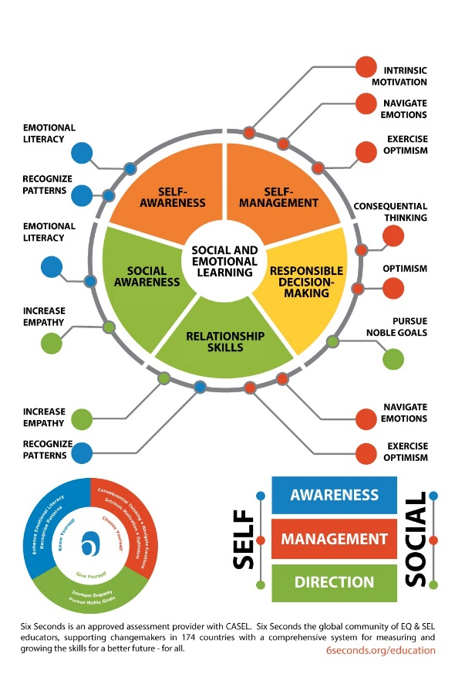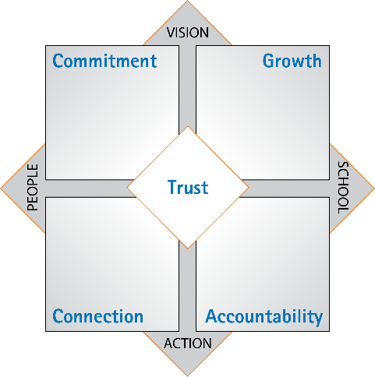

**A**

**B**

**Figure 2A.** depicts the Six Seconds Alignment Model, which focuses on bringing emotional intelligence into the classroom. The model aims to show how children and adults acquire and effectively apply the knowledge, attitudes, and skills necessary to understand and manage emotions, set and achieve positive goals, feel and show empathy for others, establish and maintain positive relationships, and make responsible decisions.

**Figure 2B.** shows the Six Seconds Education Vital Signs Model, which is assessment is a statistically validated, normed assessment of school climate that quickly identifies areas both supporting and interfering with school success.

**Figure 2: The Six Seconds Process**

In addition to providing cutting-edge instruction, The Egalitarian School has also crafted a research-practice partnership with a university. The partnership provides a novel, collaborative way to explore how educational experiences help shape brain development via the collection of both behavioral and EEG data on children ages K-8th. Therefore, The Egalitarian School’s egalitarian teaching practices, where boys and girls are exposed to inclusive teaching methods designed to mitigate sociocultural biases, such as stereotype threat, offers unique perspective on the influences of culture and biology on young, developing children.

**Participants**

A total of seventy participants took part in the two experiments. Data collection occurred on-site at The Egalitarian School, and research sessions were scheduled during the course of the day and after school. The children’s informed consent was obtained before the experiment under a protocol that was approved by the Institutional Review Board (IRB) of Stanford University. All participants were pre-screened to confirm that they had normal or corrected-to-normal visual acuity on the Bailey-Lovie constant LogMAR chart in order to make sure that they were be capable to seeing the EEG experiment stimuli presented on the screen prior to taking the assessment.

Ultimately, fourteen participants were excluded from further analyses. Excluded participants included 6 participants whose parental surveys reported that the child was born preterm or were born weighing less than 2500 grams, 6 left-handed participants as defined by the Edinburgh Handedness Inventory, 1 participant with cataracts, 1 participant who did not do the reading assessment experiment. All further analyses were performed on the remaining 56 participants (32 females, mean age 11.012 years, ± standard deviation of 1.66 years). Participants were still included even if they had anxiety disorder, history of concussion, myopia or strabismus vision issues, or diagnosed with ADHD, Dysgraphia, or Dyslexia. 1 participant had an ADHD diagnosis and 3 participants reported being previously or currently concussed.

**Data**

**Reading Assessments**

Each participant participated in a 30-minute behavioral session either before or after the EEG session. The Behavioral Session and EEG sessions were performed on the same day. The behavioral tests administered were the following: the Edinburgh Handedness Inventory (Revised version), the Test of Silent Reading Efficiency and Comprehension (TOSREC Form C), the Test of Word Reading Efficiency (TOWRE-2 Form A), and the Matrices subtest of the Kaufman Brief Intelligence Test (KBIT-2) (Lochy et al., 2015; Lochy et al., 2016).

For this paper, only TOWRE-2 scores have been evaluated. The TOWRE-2 is a reading fluency test that measures an individual’s ability to pronounce printed words fluently and accurately. Participants were asked to read as many items (real words and nonwords with no lexical meaning that can be sounded out and pronounced) as they can in 45 seconds. The test consisted of 2 subtests: (1) Sight Word Efficiency (SWE), which assesses the ability to read familiar words, and (2) Phonemic Decoding Efficiency (PDE), which measures the ability to sound out unfamiliar nonwords quickly and accurately using knowledge of letter sounds.

**EEG Conditions**

This study used a Steady State Visual Evoked Potentials (SSVEPs) paradigm. SSVEPs are signals that are natural responses to visual stimulation at specific frequencies. Using SSVEP allows researchers to carefully correlate brain activity to a stimulus at a specific time, allowing for more confidence that a research-designed stimulus and not something else is causing an oscillatory response in a participant. SSVEP works by presenting a stimulus at specific intervals of time and going back within that specific time interval post-processing to see how the participants brain reacted to said stimuli.  SVEP drastically shortens the process of data collection to only a few minutes with no explicit stimulus processing, making the experimental method an ideal tool to study children in a school setting.

The EEG study was conducted to better understand lexical and letter recognition knowledge in 3rd through 8th graders. Ultimately, neural activity associated with amplitude, or the Hz at which the brain spikes, is of interest.  EEG data was recorded while participants were presented with three SSVEP conditions at a deviant Oddball frequency of 1Hz (1 time in 1 second) and a baseline Carrier frequency of 3Hz (3 times in 1 second)—each participant sees 1 Oddball stimulus and 2 Carrier stimuli per second. The conditions were as follows:

Condition 1: Word vs PseudoFont

Condition 2: Nonword vs PseudoFont

Condition 3: Word vs Nonword

Word font is Courier New, 188 pt.

Pseudofont is BACS-2 Serif, 188 pt.

**Figure 3: Words vs Nonwords vs Pseudofonts**



Nonword font is Courier New, 188 pt.

­­

Word font is Courier New, 188 pt.

For each condition, we expect different components of reading and language to be of emphasis. For Condition 1, Words vs Pseudofonts, the response can be a mixture of lexical and letter recognition processing, but we assume letter recognition has the largest impact (Lochy et al., 2015; Lochy et al., 2016). For Condition 2, Nonwords vs Pseudofonts, the response reflects lexical processing (Lochy et al., 2015; Lochy et al., 2016). Lastly, for Condition 3, Words vs Nonwords, we expect it to be lexical only (Lochy et al., 2015; Lochy et al., 2016).

Additionally, for each condition, ten 12-second trials were presented. Each second is also equivalent to a bin (the analysis is at the bin, or second level for SSVEP) and includes the presentation of three stimuli: Oddball – Carrier – Carrier. The Carrier is the baseline, and we expect no difference here in amplitudes based off the current literature (Lynn and Mikk, 2009; Reilly, 2012; Guiso et al., 2008; Miller and Halpern, 2014; B. A. Shaywitz et al., 1995; Burman, Bitan, and Booth, 2008; Clements et al., 2006; Lochy et al., 2015; Lochy et al., 2016), while the Oddball is the deviant stimulus, a change in size of the fonts, where we might see differences in amplitude across participants. Stimuli remain on the screen for the entire duration of the Carrier frequency (333 ms).

Participants were instructed to press a button as soon as they see the font increase. Each trial has two size change occurrences, but participants are not aware of this. The size change increases in difficulty, meaning the difference between the size changes gets smaller and harder to distinguish as the participant’s performance increases.

Throughout the experimental trials, experimenters gave the participants feedback to make sure that they remain as still as possible and not move or lean forward in their seat. If needed, participants are given as long of a break as they want before they move on to the next trial. Before the presentation of each condition, there is a jitter delay of 2000ms +/- 500ms. During this time, participants are asked to fixate on a white cross in the middle of the screen. This is for control purposes and easier post processing identification.

**Rationale for Methods**

Using both behavioral data and brain data provides multimodal insights into sex differences in reading and language. To be able to provide enough power to prove significant effect size for sex, hundreds of students would have to be recruited to take reading and language assessments. However, using biological tools, such as EEG, allows for a much smaller n in order to achieve significant power. An n of 40 is very normal, even good for EEG experiments. Therefore, the data is actually quite dense, as 56 participants participated x 10 trials per person x 10 stimuli presentations per trial.

Additionally, brain data is a more technical and cutting-edge technique within the field of education. If any sort of brain data is collected in the context of sex differences, it is usually collected using a technique called fMRI (Functional Magnetic Resonance Imaging). fMRI measures brain activity by detecting changes associated with blood flow and relies on the fact that cerebral blood flow and neuronal activation are coupled. When an area of the brain is in use, blood flow to that region also increases. fMRI has great spatial resolution, but poor temporal resolution, and gives little insight into the actual synaptic processing going on prompted by an event. EEG, on the other hand, is a non-invasive, functional neuroimaging technique that records electrical activity of the brain. 128 cushioned electrodes sit on the surface of the scalp and record task-related brain waves. Every sensor produces time series data (data across time) in high temporal resolution (milliseconds). Most cortical activity is ~ 50 Hz and response time to stimulus is 10-100 milliseconds. Responses can be analyzed in the time and frequency domain. Some advantages of EEG as compared to other neuroimaging techniques include: superior temporal resolution, wide adoption due to low cost, ability to directly measure neural activity, and its ability to provide whole brain coverage from recording. Disadvantages include: Lower spatial resolution, low Signal-to-Noise-Ratio (SNR) (-20 db, 1/10th amplitude of total), the need additional filtering tools, redundant data (e.g., neighboring sensors pick up same data), high dimensionality with 100,000 data points per second, and real world stimuli cannot be used. To get around the limitation that real-world stimuli cannot be used in EEG research as there are too many confounding variables, SSVEPS are used. SSVEP has high signal-to-noise ratio (SNR) and robustness to artifacts and are conventionally analyzed at individual electrodes or linear combinations of electrodes which maximize some variant of the SNR (Dmochowski and Norcia, 2015).

Furthermore, Domochowski and Norcia developed RCA (reliable components analysis), a technique that drastically reduces the dimensionality of SSVEP data sets while retrieving physiologically plausible scalp topographies and yielding SNRs greater than the best single electrode (2015). This means that instead of using a preset brain area to watch closely, the RCA uses this across-trial reliability to decompose generalized eigenvalue problem into a small number of physiologically reliable components (RCs) (Kaneshiro et al., 2017). An eigenvalue is a number, telling you how much variance there is in the data in that direction. The eigenvector with the highest eigenvalue is therefore the most reliable component. This means it captures the most data. Instead of covariance with one matrix, RCA looks at cross covariance between two matrices. RCA allows for the best signal at all electrodes, giving us cleaner data, which will then help us understand sex differences in reading and language most effectively without using predetermined areas of interest that can often leave out valuable information in the brainscape. Both male and female EEG data were ran through the same RCA—yielding identical scalp topographies. Two components were generated, but component 1 is of main interest as it captures the most amount of data. Using EEG, SSVEP, and RCA to look at sex differences in reading and language is the best way to understand the temporal dynamics in processing as well as the amplitude differences in processing when it comes to males’ and females’ reading and language abilities.

**Results**

**Reading Assessments**

Analysis of the TOWRE-2 scores consists of using descriptive statistics to better understand sex differences between the two different assessments: SWE and PDE. A Welch Two Sample t-test was conducted to compare the mean scores of both assessments between males and females. The t-test was done to test the hypothesis that there would be no differences in mean score based off the treatment of sex and to determine if the treatment of sex actually has an effect on The Egalitarian School sample population.

**Table 1.**

**Welch Two Sample t-test: SWE Raw Final Score by Sex**

|  |  |  |  |  |
| --- | --- | --- | --- | --- |
|  | | | | |
| **T-Statistic** | **DF** | **Mean** | **SD** | **P-value** | **95 % CF** |
| 0.068196 | 45.477 | males = 79.625  females= 79.375 | males = 14.367  females = 12.443 | 0.9459 | [-7.131405, 7.631405] |

**Table 2.**

**Welch Two Sample t-test: PDE Raw Final Score by Sex**

|  |  |  |  |  |
| --- | --- | --- | --- | --- |
|  | | | | |
| **T-Statistic** | **DF** | **Mean** | **SD** | **P-value** | **95 % CF** |
| 0.25523 | 52.707 | males = 44.91667  females = 44.18750 | males = 9.929826  females = 11.38884 | 0.7995 | [-5.001729, 6.460062] |

Interestingly, for both SWE and PDE, males had a slightly higher average score than females. This conflicts with the literature presented by Lynn & Mikk (2009), Reilly (2012) and Reilly (2015) and suggest that males, on average, were able to read more sight words and unfamiliar nonwords. However, it is important to note that the difference in means is not significant. It cannot be concluded that males have better reading fluency or phonemic decoding skills. Additionally, males had a larger standard deviation than females for the SWE task, and females had a larger standard deviation for the PDE task. This might suggest that females performed closer to the mean, on average, than boys for the SWE and vice versa for the PDE task. However, ultimately, given the n = 56 (32 females, 24 males), there is not sufficient power to prove significant differences between the means of the sexes. In addition, there are more young females in the sample than males—possibly driving down the average score of females as young students are anticipated to no do as well on the SWE and PDE tasks.

Visualizing the data, we can see that the group means are very similar. For the PDE task, there was a female outlier. Both groups appear to have a normal spread, with males having a slightly larger Interquartile Range (IQR) of 19 SWE IQR and a 16.25 PDE IQR compared to females with a 17.25 SWE IQR and 14.25 PDE IQR. This hints that there is more variability in male scores between both tasks as suggested by Hedges and Nowell (1995). Additionally, for the PDE task, there was one female outlier (1.5 x IQR), contrasting the literature that more males would be “low performance” outliers. However, since it is only one participant, nothing can be concluded.

**Figure 3.**

Comparing SWE Raw Scores and PDE Raw Scores By Sex.

**SWE Raw Scores by Sex PDE Raw Scores by Sex**

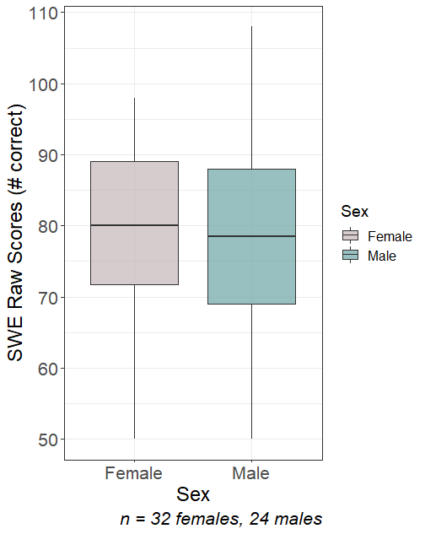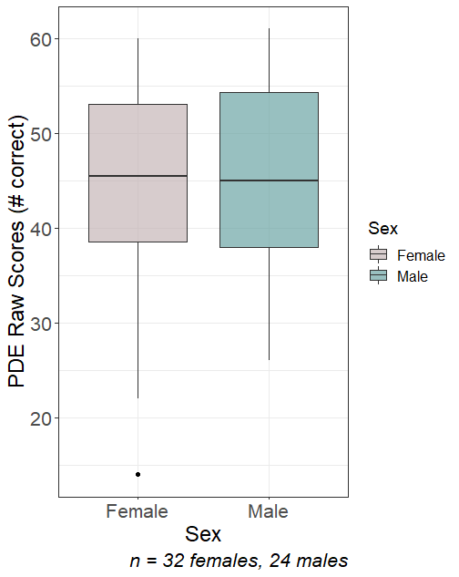

Therefore, evaluating sex differences in reading and language using reading assessment data needs further sampling to increase the population. Doing so would provide greater reliability and generalizability of the results as well as provide insight into how The Egalitarian School student sample compares to the student population at large as well as to other schools. In the future, including schools with different pedagogies and different levels of SES would be interesting points of comparison to The Egalitarian School’s methodology and student body composition.

**EEG Analysis**

Male and female data were trained on the same RCA—yielding the same scalp topographies, and two components were selected, with Component 1 being of most interest as it contains the most data. Post-processed EEG data in the form of Root-sum Squares (RSS) Projected Amplitudes were provided to me for all conditions to analyze proposed sex differences. To calculate the "Projected Amplitude" the unit circle is used. Technically, the "Amplitude" is the data projected through the scalp topography produced by RCA, but the "Projected Amplitude" means that the individual amplitudes are re-calculated as they are projected to the mean amplitude to get rid of phase differences. Phase differences describe the difference in degrees or radians between the brain waves of individual participants. The RSS method yields one mean projected amplitude for all the stimuli—Carrier and Oddball—for males and females.

In order to evaluate the independent variable of sex on brain amplitude for The Egalitarian School student sample during EEG reading tasks, I constructed a multilevel linear model with fixed effects of sex, condition, and age, and a random effect of individual participant ID. In addition, condition was also a repeated measure. The random effects assumption is that the individual-specific effects are uncorrelated with the independent variables. The random effects on individual participant ID accounts for things like individual differences in processing speed or other things that we can’t quite control for. Contrastingly, the fixed effect assumption is that the individual-specific effects are correlated with the independent variables. I anticipate sex, age, and condition being correlated with RSS Projected Amplitude (Lynn & Mikk, 2009; Reilly, 2012; Guiso et al., 2008; Miller & Halpern, 2014; B. A. Shaywitz et al., 1995; Burman, Bitan, & Booth, 2008; Clements et al., 2006). I also anticipate that the Oddball Condition will have more of an RSS Projected Amplitude response than the baseline Carrier Condition (Lochy et al., 2015; Lochy et al., 2016) and that there are some difference between RSS Projected Amplitude responses between males and females (Lynn & Mikk, 2009; Reilly, 2012; Guiso et al., 2008; Miller & Halpern, 2014; B. A. Shaywitz et al., 1995; Burman, Bitan, & Booth, 2008; Clements et al., 2006).

**Linear Mixed Effects Model**

**Bare Model:**

*Yij = β0 + β1X1 + Ui  + eij*

Where *Yij* is equal to the value*, i* is equal to participant*, j* is equal to timepoint*, β0 + β1X1* are fixed effects, *Ui  is the random effect, and eij* is the individual and time specific error.

**Restricted Model:**

*Amplitudeij = β0 + β1X1 + Participanti  + eij*

Where *Yij* is equal to the RSS Projected Amplitude*, i* is equal to participant*, j* is equal to repeated condition*, β0 + β1 X1* are fixed effects, *Participanti  is the random effect, and eij* is the individual and time specific error.

Therefore, the full models is as follows:

**Full Model:**

*Amplitudeij = β0 + β1sexij + β2conditionij + β3 sexij *conditionij + β4ageij + Participanti  + eij*

Where *Amplitudeij* is equal to the value of the RSS Projected Amplitude*, i* is equal to participant*, j* is equal to timepoint condition*, β0 + β1 sexij + β2 conditionij* are fixed effects, *β3 sexij *conditionij* is the interaction between the fixed effects*, β4ageij* is a control variable*, Participanti* is the random effect*, and eij* is the individual and time specific error.

The full multilevel linear model was tested against the restricted model (participant ID only) using an ANOVA (Delta AIC (Δi) = - 440.8)—including the fixed effects improved the model as lower AIC values indicate a better fit (Burnham and Anderson, 2004). AIC was evaluated knowing that the AIC tries to select the model that most adequately describes an unknown, high dimensional reality—which is reflective of the RSS Projected Amplitude. This means that reality is never in the set of candidate models that are being considered, similar to how individual RSS Projected Amplitude is influenced by so many different factors. BIC between the restricted model and the full model did not change. However, ultimately, when looking at the delta AIC, the inclusion of sex, condition, and age improved the model.

Additionally, the p-value for the chi-square value of the ANOVA between the restricted model and the full model was <.001 indicating that there is sufficient evidence to conclude that the observed full model distribution is not the same as the restricted expected distribution. Furthermore, age was included as a control variable as age can affect other variables such as RSS Projected Amplitude. A preliminary explorative model with age as a fixed effect instead of a control variable yielded a higher AIC value than the restricted model, suggesting age as a fixed effect did not improve modeling the data. Furthermore, it must be noted that the study design was unbalanced—with more females being in the younger age category than males. This is why age was selected as a control. In addition, sex is the main variable of interest and controlling for age allowed to highlight a two-way interaction between sex and condition. Lastly, my reference variable for the multilevel linear regression was baseline Carrier Condition 1, Component 2. This variable was chosen as a reference category because it yields the most interpretable p-values for our main variables of interest—the deviant Oddball response at Component 1 across all conditions.

Running the multilevel mixed linear model yielded significant differences (p < .001) in RSS Projected Amplitude across Carrier Condition 1, Component 1; Carrier Condition 2, Component 1; Carrier Condition 3, Component 1; Oddball Condition 1, Component 1; and Oddball Condition 2, Component 1 compared to the reference variable of Carrier Condition 1, Component 2 (see Table 3 in Appendix). This suggests that significantly different brain responses were happening according to stimulus frequency across condition. This aligns with Lochy et al.’s findings (2015; 2016) indicating that RSS Projected Amplitude differs across lexical and letter recognition processing.

Additionally, age is a significant control variable. Literature research showing brain differences in reading across age groups also supports this (Lochy et al., 2015; Lochy et al., 2016). Moreover, condition and sex are significant predictors of RSS Projected Amplitude. There are significant interactions between Sex and Carrier Condition 2, Component 1 (p<0.05), sex and Oddball Condition 1, Component 1(p<0.001), and sex and Oddball Condition 2, Component 1 (p<0.05). Females had significantly higher RSS Amplitudes at the p<0.05-level for Carrier Condition 2, Component 1. This suggests females utilized significantly more cognitive effort to distinguish between Nonwords vs PseudoFonts for the Carrier frequency. This contrasts with Lochy’s hypothesis that all responses at baseline Carrier stimulus are the same (2015; 2016). Moreover, for Oddball Condition 1, Component 1, males have significantly higher RSS Projected Amplitude than females at the p<0.001-level. This suggests that males use significantly more cognitive effort to distinguish between Words vs PseudoFonts at the deviant Oddball frequency. Lastly, males have significantly higher RSS Amplitudes at the p<0.05-level for Oddball Condition 2, Component 1 (p<0.05) This suggests males use more cognitive effort to distinguish between Nonwords vs PseudoFonts for the Oddball Stimulus. All findings pertaining to sex differences for Oddball and Carrier stimuli across conditions are novel.

**Figure 5. RSS Projected Amplitude by Condition and Sex – Real Carrier Values**

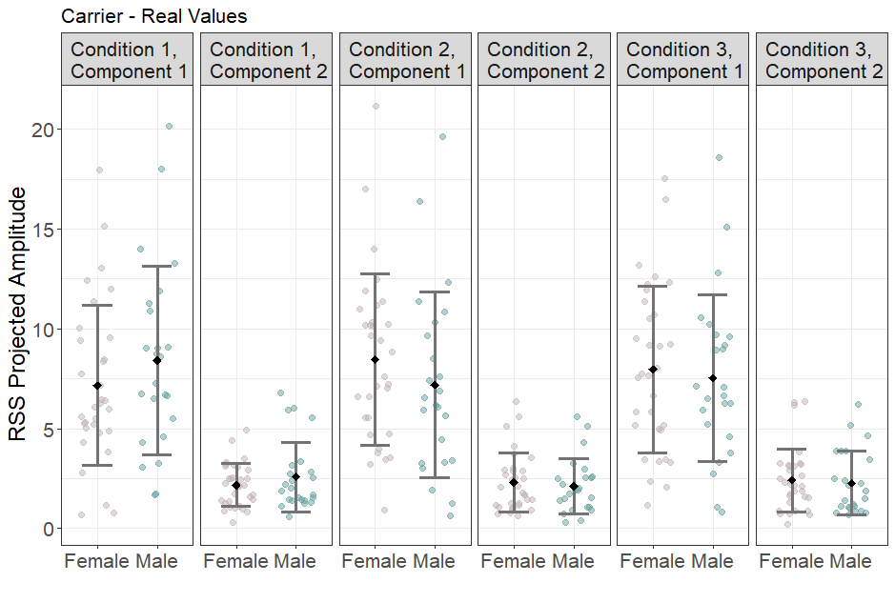Figure 5. depicts the real RSS Projected Amplitudes for individuals across conditions and components for the Carrier frequency. Error bars of the standard deviation (SD) SD indicate dispersion of the data from mean. A 95% confidence interval was used. See Table 4 in Appendix for more Summary Statistics.

This figure shows significant differences between RSS Projected Amplitudes at Carrier Condition 1, Component 1; Carrier Condition 2, Component 1; Carrier Condition 3, and Component 1 compared to the reference variable of Carrier Condition 1, Component 2 (see Appendix for values). This suggests that even at the baseline Carrier frequency where stimuli are presented at 3Hz (3 times in 1 second), there are significant differences in RSS Projected Amplitude. This is indicative that the brain responds differently to interpreting Words vs Pseudofonts, Nonwords vs Pseudofonts, and Words vs Nonwords. This translates to the brain having significantly different RSS Projected Amplitude responses for letter recognition and lexical processing (Lochy et al., 2015; Lochy et al., 2016). Additionally, females had significantly higher RSS Amplitudes at the p<0.05-level for Carrier Condition 2, Component 1. This suggests that females must utilize more cognitive effort to distinguish between Nonwords vs Pseudofonts at the Carrier frequency.

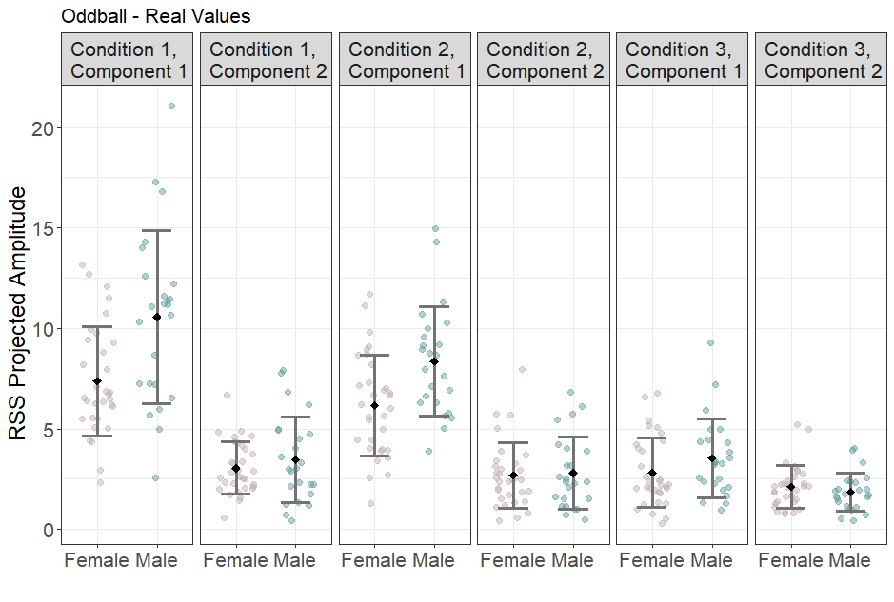**Figure 6. RSS Projected Amplitude by Condition and Sex – Real Oddball Values**

Figure 6. depicts the real RSS Projected Amplitudes for individuals across conditions and components for the Oddball frequency. Error bars of the standard deviation (SD) SD indicate dispersion of the data from mean. A 95% confidence interval was used. See Table 5 in Appendix for more Summary Statistics.

This figure shows significant differences between RSS Projected Amplitudes at Oddball Condition 1, Component 1; and Oddball Condition 2, Component 1 compared to the reference variable of Carrier Condition 1, Component 2 (see Table 3 in Appendix). This suggests that at the deviant Oddball stimulus where stimuli are presented at 1Hz (1 time in 1 second), there are significant differences in RSS Projected Amplitude. This is indicative that the brain responds differently to interpreting Words vs Pseudofonts, Nonwords vs Pseudofonts, and Words vs Nonwords. This translates to the brain having significantly different RSS Projected Amplitude responses for letter recognition and lexical processing when stimuli are presented at the Oddball frequency (Lochy et al., 2015; Lochy et al., 2016). Additionally, for the Oddball response, males seem to have significantly higher RSS Projected Amplitude. For Oddball Condition 1, Component 1, males have significantly higher RSS Projected Amplitude than females at the p<0.001-level. This suggests that males use significantly more cognitive effort to distinguish between Words vs PseudoFonts at the deviant Oddball frequency. Lastly, males have significantly higher RSS Amplitudes at the p<0.05-level for Oddball Condition 2, Component 1 (p<0.05). This suggests that males must utilize more cognitive effort to distinguish between Nonwords vs Pseudofonts at the Oddball frequency.

**Figure 7. Mean Predicted RSS Projected Amplitude by Condition and Sex** 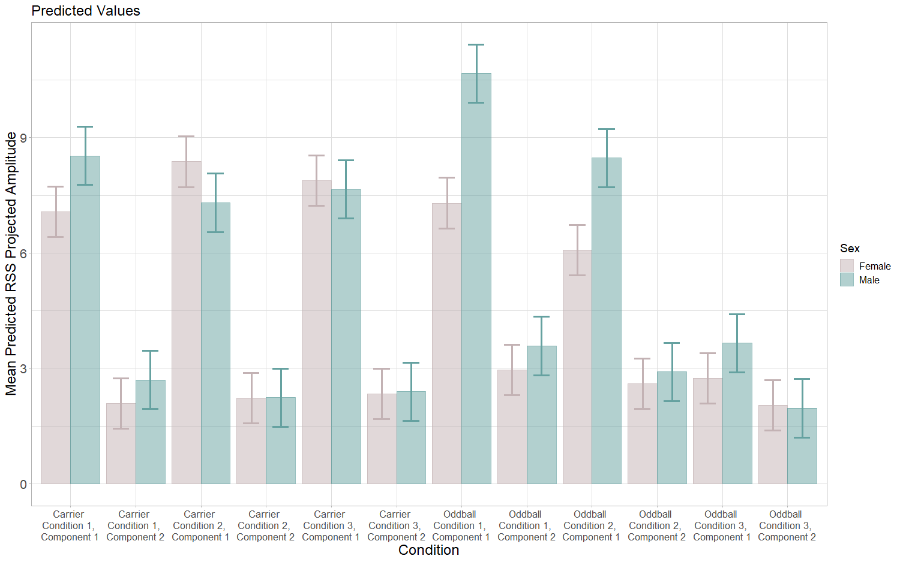

Figure 7. shows the mean predicted RSS Amplitude by Condition and Sex. Predicted values were generated from the multilevel linear regression. Mean predicted values are displayed with a 83.4% confidence interval which allows viewers to easily compare groups. Instances where error bars don’t overlap indicates 95% confidence (Knol et al., 2011). See Table 6 and 7 in Appendix for Summary Statistics.

Predicted values were generated from the linear model not using the random effect of participant. There remains significant sex differences in RSS Projected Amplitude at Oddball Condition 1, Component 1 and Oddball Condition 2, Component 1. In addition, there are now significant sex differences at Carrier Condition 1, Component 1 and no longer significant sex differences at Carrier Condition 2, Component 1. The predictive values support that there are significant sex differences in RSS Projected Amplitude at Oddball Condition 1, Component 1 and Oddball Condition 2, Component 1 at the p<0.05-level.

**Discussion**

It must be noted that deriving greater "cognitive effort" from higher amplitude scores just not reflect level of intelligence. Simply, this could indicate that neural pathways for females are more efficient at processing Words vs Pseudofonts and Nonwords vs Pseudofonts than males, as suggested by B. A. Shaywitz et al. (1995), Burman, Bitan, & Booth (2008), Clements et al. (2006). Interestingly, however, another study evaluating the same RSS Projected Amplitudes using a high and low reading score split found that poor readers had higher amplitudes (in review). Currently, it is unknown higher males and poor readers would have higher RSS Projected Amplitude Values. One such explanation for these observed sex differences seldom explored in recent research is neurodiversity. Neurodiversity is a term that refers to variation in the human brain regarding sociability, learning, attention, mood and other mental functions (Singer, 1999). Neurodiversity applies to individuals that have a diagnosis or identify with Autism Spectrum Disorder, Attention Deficit (Hyperactivity) Disorder, Dyslexia, and a multitude of variations. Interestingly, biological males are between four and five times more likely to be diagnosed with ASD each year then biological females (Firth & Mira, 1992). The rate for ASD is 1 in 34 among boys (or 2.97 percent) and 1 in 145 among girls (or 0.69 percent) (Frith & Mira, 1992). Through the modern surge in diagnoses and the intensive investigations into this phenomenon that followed, that ratio has remained relatively static. ADHD and Dyslexia are inherently male-biased as well, according to the most recent research (Arnett et al., 2015)—at a rate thought to be around 3 or 4 times more common in biological boys than biological girls (NIMH). However, within the context of sex differences for specific cognitive abilities, specifically for reading and language, there is a very little research citing neurodiversity as a possible explanation for the observed outperformance of males by females.

When it comes to neurodiversity in the context of reading and language, there is a large spectrum of performance and biological mechanisms underlying the individualized processing behind these tasks. On one hand, individuals with Dyslexia and ADHD struggle with reading comprehension, reading fluency, and orthographic processing (Wagner & Torgesen, 1987; Siegel 10 & Faux, 1989; Piasta & Wagner, 2008; Miller et al., 2011). On the other hand, it has been noted that children with ASD are often extremely talented readers at an unusual age (Richman & Wood, 2002; Greven et al., 2011). Therefore, within the neurodiversity community there is a spread of both low and high performers. Given that neurodiversity is male-biased, this spectrum of performance could possibly explain the larger variability seen in males on reading and language tasks (Reilly, 2015). However, how neurodiversity fits in with observations of sex differences in specific cognitive tasks remains understudied. Further research is needed to better understand the possible connection between these two phenomena.

Additionally, further studies looking at schools not practicing SEL and egalitarian pedagogy must be conducted to confirm that egalitarian teaching practices mitigate sex difference in specific cognitive tasks like reading and language. However, it must be noted that students at The Egalitarian School might experience a more homogenous, less-gendered environment than their public school counterparts. Studies exploring sex differences in RSS Projected Amplitudes for reading and language tasks at public schools should expect even larger sex differences than seen at The Egalitarian School. However, as of now, this study cannot be generalized because of the specific teaching pedagogy of The Egalitarian School. In the future, it would be advised to do a study with different schools with different SES backgrounds that implement different teaching pedagogies.

Lastly, teacher quality and attention dedicated in the classroom and at home to reading activities was not controlled. Sociocultural bias and gender-status bias that males should spend more time on STEM tasks and physical experiments (Holbrook, 1991) could be influencing biological processing of reading and language tasks via epigenetics and neuroplasticity. Education leaders should be trained in egalitarian pedagogy to ensure equal treatment of students to lessen gender-status beliefs and stereotype threat. Parents should also be exposed to the relationship between gender-status beliefs, epigenetics and neuroplasticity, and specific cognitive tasks. Future studies could potentially consist of controlled, longitudinal reading intervention treatments to ensure that male and female students are exposed the same quality of instruction as well as the same amount of individualized attention, both at home and at school.

**Table 3. Regression Table for Full Linear Model**

|  |  |
| --- | --- |
|  | |
|  | *Dependent variable:* |
|  |  |
|  | RSS Projected Amplitude  **Estimate** |
|  | |
| Sex-Male | 0.605 |
|  | t = 0.837 |
|  |  |
| **Carrier Condition 1, Component 1** | **4.983** |
|  | **t = 7.571\*\*\*** |
|  |  |
| **Carrier Condition 2, Component 1** | **6.282** |
|  | **t = 9.545\*\*\*** |
|  |  |
| Carrier Condition 2, Component 2 | 0.130 |
|  | t = 0.197 |
|  |  |
| **Carrier Condition 3, Component 1** | **5.787** |
|  | **t = 8.793\*\*\*** |
|  |  |
| Carrier Condition 3, Component 2 | 0.247 |
|  | t = 0.375 |
|  |  |
| **Oddball Condition 1, Component 1** | **5.205** |
|  | **t = 7.908\*\*\*** |
|  |  |
| Oddball Condition 1, Component 2 | 0.870 |
|  | t = 1.322 |
|  |  |
| **Oddball Condition 2, Component 1** | **3.980** |
|  | **t = 6.047\*\*\*** |
|  |  |
| Oddball Condition 2, Component 2 | 0.512 |
|  | t = 0.778 |
|  |  |
| Oddball Condition 3, Component 1 | 0.645 |
|  | t = 0.980 |
|  |  |
| Oddball Condition 3, Component 2 | -0.059 |
|  | t = -0.090 |
|  |  |
| **Age** | **-0.282** |
|  | **t = -3.843\*\*\*** |
|  |  |
| Sex-Male:Carrier Condition 1, Component 1 | 0.848 |
|  | t = 0.843 |
|  |  |
| **Sex-Male:Carrier Condition 2, Component 1** | **-1.674** |
|  | **t = -1.665\*** |
|  |  |
| Sex-Male:Carrier Condition 2, Component 2 | -0.588 |
|  | t = -0.585 |
|  |  |
| Sex-Male:Carrier Condition 3, Component 1 | -0.831 |
|  | t = -0.827 |
|  |  |
| Sex-Male:Carrier Condition 3, Component 2 | -0.550 |
|  | t = -0.547 |
|  |  |
| **Sex-Male:Oddball Condition 1, Component 1** | **2.764** |
|  | **t = 2.749\*\*\*** |
|  |  |
| Sex-Male:Oddball Condition 1, Component 2 | 0.013 |
|  | t = 0.013 |
|  |  |
| **Sex-Male:Oddball Condition 2, Component 1** | **1.790** |
|  | **t = 1.781\*** |
|  |  |
| Sex-Male:Oddball Condition 2, Component 2 | -0.304 |
|  | t = -0.303 |
|  |  |
| Sex-Male:Oddball Condition 3, Component 1 | 0.310 |
|  | t = 0.308 |
|  |  |
| Sex-Male:Oddball Condition 3, Component 2 | -0.676 |
|  | t = -0.672 |
|  |  |
| **Constant** | **5.199** |
|  | **t = 5.666\*\*\*** |
|  |  |
|  | |
| Observations | 672 |
| Log Likelihood | -1,612.519 |
| Akaike Inf. Crit. | 3,279.038 |
| Bayesian Inf. Crit. | 3,400.815 |
|  | |
| *Note:* | **\*p<0.05, **p<0.01, ***p<0.001** |

(Delta AIC (Δi) = - 440.8) for Restricted vs Full Model

**Table 4. Summary Statistics for Carrier Frequency**

|  |  |  |  |  |  |  |
| --- | --- | --- | --- | --- | --- | --- |
|  | **Carrier – RSS Projected Amplitude** | | | | | |
|  | **Mean** | | **Standard**  **Deviation** | | **Standard**  **Error** | |
|  | **Males** | **Females** | **Males** | **Females** | **Males** | **Females** |
| Condition 1, Component 1 | 8.418 | 7.159 | 4.713 | 4.009 | 0.257 | 0.218 |
| Condition 1, Component 2 | 2.587 | 2.176 | 1.737 | 1.079 | 0.0948 | 0.0589 |
| Condition 2, Component 1 | 7.195 | 8.458 | 4.644 | 4.276 | 0.253 | 0.233 |
| Condition 2, Component 2 | 2.128 | 2.305 | 1.372 | 1.459 | 0.075 | 0.0796 |
| Condition 3, Component 1 | 7.544 | 7.963 | 4.184 | 4.170 | 0.228 | 0.228 |
| Condition 3, Component 3 | 2.285 | 2.423 | 1.588 | 1.569 | 0.087 | 0.0856 |

**Table 5. Summary Statistics for Oddball Frequency**

|  |  |  |  |  |  |  |
| --- | --- | --- | --- | --- | --- | --- |
|  | **Oddball – RSS Projected Amplitude** | | | | | |
|  | **Mean** | | **Standard**  **Deviation** | | **Standard**  **Error** | |
|  | **Males** | **Females** | **Males** | **Females** | **Males** | **Females** |
| Condition 1, Component 1 | 10.5564 | 7.381 | 4.292 | 2.715 | 0.166 | 0.108 |
| Condition 1, Component 2 | 3.471 | 3.046 | 2.142 | 1.295 | 0.083 | 0.050 |
| Condition 2, Component 1 | 8.358 | 6.156 | 2.732 | 2.520 | 0.105 | 0.097 |
| Condition 2, Component 2 | 2.795 | 2.688 | 1.811 | 1.629 | 0.0699 | 0.063 |
| Condition 3, Component 1 | 3.542 | 2.821 | 1.964 | 1.716 | 0.076 | 0.066 |
| Condition 3, Component 3 | 1.852 | 2.117 | 0.945 | 1.049 | 0.036 | 0.040 |

|  |  |  |  |  |  |  |
| --- | --- | --- | --- | --- | --- | --- |
|  | **Carrier – Predicted RSS Projected Amplitude** | | | | | |
|  | **Mean** | | **Standard**  **Deviation** | | **Standard**  **Error** | |
|  | **Males** | **Females** | **Males** | **Females** | **Males** | **Females** |
| Condition 1, Component 1 | 8.418 | 7.159 | 0.5060373 | 0.5060373 | 0.02926062 | 0.02760660 |
| Condition 1, Component 2 | 2.587 | 2.176 | 0.5060373 | 0.5060373 | 0.02926062 | 0.02760660 |
| Condition 2, Component 1 | 7.195 | 8.458 | 0.5060373 | 0.5060373 | 0.02926062 | 0.02760660 |
| Condition 2, Component 2 | 2.128 | 2.305 | 0.5060373 | 0.5060373 | 0.02926062 | 0.02760660 |
| Condition 3, Component 1 | 7.544 | 7.963 | 0.5060373 | 0.5060373 | 0.02926062 | 0.02760660 |
| Condition 3, Component 3 | 2.285 | 2.423 | 0.5060373 | 0.5060373 | 0.02926062 | 0.02760660 |

**Table 6. Summary Statistics for Carrier Frequency – Predicted Values**

**Table 7. Summary Statistics for Carrier Frequency – Predicted Values**

|  |  |  |  |  |  |  |
| --- | --- | --- | --- | --- | --- | --- |
|  | **Oddball – Predicted RSS Projected Amplitude** | | | | | |
|  | **Mean** | | **Standard**  **Deviation** | | **Standard**  **Error** | |
|  | **Males** | **Females** | **Males** | **Females** | **Males** | **Females** |
| Condition 1, Component 1 | 10.5564 | 7.381 | 0.5060373 | 0.5060373 | 0.02926062 | 0.02760660 |
| Condition 1, Component 2 | 3.471 | 3.046 | 0.5060373 | 0.5060373 | 0.02926062 | 0.02760660 |
| Condition 2, Component 1 | 8.358 | 6.156 | 0.5060373 | 0.5060373 | 0.02926062 | 0.02760660 |
| Condition 2, Component 2 | 2.795 | 2.688 | 0.5060373 | 0.5060373 | 0.02926062 | 0.02760660 |
| Condition 3, Component 1 | 3.542 | 2.821 | 0.5060373 | 0.5060373 | 0.02926062 | 0.02760660 |
| Condition 3, Component 3 | 1.852 | 2.117 | 0.5060373 | 0.5060373 | 0.02926062 | 0.02760660 |

**Bibliography**

Babad, E. (2009). The social psychology of the classroom. New York: Routledge

Berninger VW, Raskind W, Richards T, Abbott R, Stock P. A multidisciplinary approach to understanding developmental dyslexia within working-memory architecture: genotypes, phenotypes, brain, and instruction. Dev Neuropsychology. 2008;33(6):707-44. doi:

10.1080/87565640802418662. PMID: 19005912.

Bian, Lin, Sarah-Jane Leslie, and Andrei Cimpian. 2017. “Gender Stereotypes about Intellectual Ability Emerge Early and Influence Children’s Interests.” Science

355(6323):389–91.

Buchmann, Claudia, and Thomas A. DiPrete. 2006. “The Growing Female Advantage in College Completion: The Role of Family Background and Academic Achievement.” American Sociological Review 71(4):515–41.

Burman, D. D., Bitan, T., and Booth, J. R. (2008). Sex differences in neural processing of language among children. Neuropsychology, 46, 1349 – 1362. <http://dx.doi.org/10.1016/j.neuropsychologia.2007.12.021>

Burnham, K., & Anderson, D. R. (2004). Multimodel inference: Understanding AIC and BIC in model selection. Sociological Methods & Research, 33(2), 261–304.

Camarata, S., and Woodcock, R. (2006). Sex differences in processing speed: Developmental effects in males and females. Intelligence, 34, 231–252.

<http://dx.doi.org/10.1016/j.intell.2005.12.001>

Caplan, J. B., and Caplan, P. J. (2016). Thinking critically about research on sex and gender (3rd

ed.). New York, NY: Routledge.

Caplan, P. J., and Caplan, J. B. (1997). Do sex-related cognitive differences exist, and why do people seek them out? In P. J. Caplan, M. Crawford, J. S. Hyde, and J. T. E. Richardson (Eds.), Gender differences in human cognition (pp. 52– 80). New York, NY: Oxford

Castles, A., and Coltheart, M. (2004). Is there a causal link from phonological awareness to success in learning to read? Cognition, 91, 77-111. doi:10.1016/S0010-0277(03)00164-1 University Press. http:// dx.doi.org/10.1093/acprof:oso/9780195112917.003.0003

Chrisler JC, McCreary DR (2010). [*Handbook of Gender Research in Psychology: Volume 1:*](https://books.google.com/books?id=Xtq0M1f_aIMC&pg=PA302)

[*Gender Research in General and Experimental Psychology*.](https://books.google.com/books?id=Xtq0M1f_aIMC&pg=PA302) [Springer Science and Business](https://en.wikipedia.org/wiki/Springer_Science_%26_Business_Media)

[Media.](https://en.wikipedia.org/wiki/Springer_Science_%26_Business_Media) p. 302. [ISBN](https://en.wikipedia.org/wiki/ISBN_(identifier)) [978-1441914651.](https://en.wikipedia.org/wiki/Special:BookSources/978-1441914651)

Clements, A. M., Rimrodt, S. L., Abel, J. R., Blankner, J. G., Mostofsky, S. H., Pekar, J. J., Cutting, L. E. (2006). Sex differences in cerebral laterality of language and visuospatial processing. Brain and Language, 98, 150 –158. <http://dx.doi.org/10.1016/j.bandl.2006.04.007>

Cvencek, D., Meltzof, A. N., and Greenwald, A. G. (2011). Math-gender stereotypes in elementary school children. Child Development, 82, 766–779.

Darley, J. M., and Fazio, R. H. (1980). Expectancy conformation processes arising in the social interaction sequence. American Psychologist, 35, 867–881

Denmark, Florence L.; Paludi, Michele A. (2008). [*Psychology of Women: A Handbook of Issues and Theories*](https://archive.org/details/psychologywomenh00denm) (2nd ed.). Westport, Conn.: Praeger. pp. [7–](https://archive.org/details/psychologywomenh00denm/page/n27)11. [ISBN](https://en.wikipedia.org/wiki/ISBN_(identifier)) [978](https://en.wikipedia.org/wiki/Special:BookSources/978-0275991623) [0275991623.](https://en.wikipedia.org/wiki/Special:BookSources/978-0275991623)

Dmochowski, J. P., Greaves, A. S., and Norcia, A. M. (2015). Maximally reliable spatial filtering of steady state visual evoked potentials. Neuroimage, 109, 63-72.

Dupont C, Armant DR, Brenner CA (2009). "Epigenetics: definition, mechanisms and clinical perspective". Seminars in Reproductive Medicine. 27 (5): 351–7. doi:10.1055/s-0029-1237423.

Eccles, J., Jacobs, J. E., and Harold, R. D. (1990). Gender role stereotypes, expectancy efects, and parents’ socialization of gender diferences. Journal of Social Issues, 46, 183–201.

Fine C (2005). [*Delusions of Gender: The Real Science Behind Sex Differences*.](https://books.google.com/books?id=JbdkAgAAQBAJ&pg=PT96) [Icon Books.](https://en.wikipedia.org/wiki/Icon_Books)

p. 96. [ISBN](https://en.wikipedia.org/wiki/ISBN_(identifier)) [1848313969.](https://en.wikipedia.org/wiki/Special:BookSources/1848313969)

Foulin, J. N. (2005). Why is letter-name knowledge such a good predictor of learning to read? Reading and Writing, 18, 129-155. doi:10.1007/s11145-004-5892-2

Furnham, Adrian, Emma Reeves, and Salima Budhani. 2002. “Parents Think Their Sons Are Brighter Than Their Daughters: Sex Differences in Parental SelfEstimations and Estimations of Their Children’s Multiple Intelligences.” The Journal of Genetic Psychology 163(1):24–39.

Freese, J. (2018). The Arrival of Social Science Genomics. Contemporary Sociology, 47(5), 524–536. https://doi.org/10.1177/0094306118792214a

Gisborne, Thomas. *Enquiry into the Duties of the Female Sex., M.a*. GALE ECCO, PRINT

EDITIONS, 2018.

Guiso, L., Monte, F., Sapienza, P., and Zingales, L. (2008). Diversity: Culture, gender, and math.

Science, 320, 1164 –1165. http://dx.doi.org/ 10.1126/science.1154094

Halpern, D. F. (2000). Sex differences in cognitive abilities (3rd ed.). Mahwah, NJ: Erlbaum.

Hedges LV, Nowell A. Sex differences in mental test scores, variability, and numbers of high scoring individuals. Science. 1995 Jul 7;269(5220):41-5. doi: 10.1126/science.7604277.

PMID: 7604277.

Holbrook, S. (1991). Women's Work: The Feminizing of Composition. *Rhetoric Review,* *9*(2), Retrieved March 14, 2021, from http://www.jstor.org/stable/465908

Hyde, J. S. (2005). The gender similarities hypothesis. American Psychologist, 60, 581–592. <http://dx.doi.org/10.1037/0003-066X.60.6.581>

Jussim, L., Eccles, J., and Madon, S. (1996). Social perception, social stereotypes, and teacher expectations: Accuracy and the quest for the powerful self-fulflling prophecy. Advances in Experimental Social Psychology, 28(C), 281–388

Kaiser, A., Haller, S., Schmitz, S., and Nitsch, C. (2009). On sex/gender related similarities and differences in fMRI language research. Brain Research Brain Research Reviews, 61, 49

. http://dx.doi.org/10.1016/ j.brainresrev.2009.03.005

Kaneshiro B, Nguyen D, Norcia D, Dmochowski Jacek, and Berger J (2020). Natural Music

Evokes Correlated EEG Responses Reflecting Temporal Structure and Beat. NeuroImage. 214, 116559. doi:10.1016/j.neuroimage.2020.116559

Knol, M.J., Pestman, W.R. & Grobbee, D.E. (2011). The (mis)use of overlap of confidenceintervals to assess effect modification. Eur J Epidemiol 26, 253–254. https://doi.org/10.1007/s10654-011-9563-8

Levy, J. (1969). Possible basis for the evolution of lateral specialization of the human brain.

Nature, 224, 614 – 615. http://dx.doi.org/10.1038/ 224614a0

Lochy, A., Van Belle, G., and Rossion, B. (2015). A robust index of lexical representation in the left occipito-temporal cortex as evidenced by EEG responses to fast periodic visual stimulation. Neuropsychologia, 66, 18-31.

Lochy, A., Van Reybroeck, M., and Rossion, B. (2016). Left cortical specialization for visual letter strings predicts rudimentary knowledge of letter-sound association in preschoolers. Proceedings of the National Academy of Sciences, 113(30), 8544-8549.

Lynn, R., and Mikk, J. (2009). Sex differences in reading achievement. Trames, 13, 3–13 <http://dx.doi.org/10.3176/tr.2009.1.01>

Miller, D. I., and Halpern, D. F. (2014). The new science of cognitive sex differences. Trends i

Cognitive Sciences, 18, 37– 45. http://dx.doi.org/ 10.1016/j.tics.2013.10.011

Musto, M. (2019). Brilliant or Bad: The Gendered Social Construction of Exceptionalism in Early Adolescence. American Sociological Review, 84(3), 369–393. https://doi.org/10.1177/0003122419837567

Nguyen, H. H., and Ryan, A. M. (2008). Does stereotype threat afect test performance of minorities and women? A meta-analysis of experimental evidence. Journal of Applied Psychology, 93, 1314–1334.

Norton, James J. S.; Umunna, Stephen; Bretl, Timothy (2017). "The elicitation of steady-state visual evoked potentials during sleep". Psychophysiology. 54 (4): 496–507. doi:10.1111/psyp.12807. ISSN 0048-5772.

Petersen, Jennifer. 2013. “Gender Differences in Identification of Gifted Youth and in Gifted Program Participation: A Meta-Analysis.” Contemporary Educational Psychology 38(4):342–48.

Purao, Sandeep. (2014). Towards an Egalitarian Pedagogy for the Millennial Generation: A Reflection. Innovative Practices in Teaching Information Sciences and Technology: Experience Reports and Reflections. 43-51. 10.1007/978-3-319-03656-4_5.

Rampogal. K (2019). Inside the Stanford Marriage Pact. https://www.stanforddaily.com/2019/02/19/inside-the-stanford-marriage-pact/

Reilly, D. (2012). Gender, culture, and sex-typed cognitive abilities. PLoS ONE, 7(7), e39904. http://dx.doi.org/10.1371/journal.pone.0039904 Reilly, D. (2015). Gender differences in reading from a cross-cultural perspective: The contribution of gender equality. Paper presented at the International Convention of Psychological Science, Amsterdam,

Netherlands. http://dx.doi.org/10.13140/RG.2.2.18218.72647

Reilly, D., Neumann, D. L., and Andrews, G. (2015). Sex differences in mathematics and science: A meta-analysis of National Assessment of Educational Progress assessments. Journal of Educational Psychology, 107, 645– 662. <http://dx.doi.org/10.1037/edu0000012>

Reznikov, Leah R.; Fadel, Jim R.; Reagan, Lawrence P. (2012). "Glutamate-mediated neuroplasticity deficits in mood disorders". In Costa e Silva, J. A.; Macher, Jean-Paul; Olié, Jean-Pierre (eds.). Neuroplasticity: New biochemical mechanisms. SpringerLink : Bücher. London: Springer Healthcare. p. 13. ISBN 9781908517180.

Robnett, R. D. (2016). Gender bias in stem felds: Variation in prevalence and links to stem self concept. Psychology of Women Quarterly, 40, 65–79.

Shilt, Kristen. (2010). Just one of the Guys? Transgender Men and the Persistence of Gender Inequality. The University of Chicago Press, Chicago.

Shaywitz, B. A., Shaywitz, S. E., Pugh, K. R., Constable, R. T., Skudlarski, P., Fulbright, R. K.,

(1995). Sex differences in the functional organization of the brain for language. Nature,

373, 607– 609. http://dx .doi.org/10.1038/373607a0.

Snyder, Thomas D., and Sally A. Dillow. 2012. “Digest of Education Statistics 2011.” National Center for Education Statistics. Washington, DC: U.S. Department of Education.

Thébaud, Sarah, and Maria Charles. 2018. “Segregation, Stereotypes, and STEM.” Social Sciences 7(111):1–18. Thorne, Barrie. 1993. Gender Play: Girls and Boys in School. New Brunswick, NJ: Rutgers University Press

Trusz, S. (2020). Why do females choose to study humanities or social sciences, while males prefer technology or science? Some intrapersonal and interpersonal predictors. SocEduc . https://doi.org/10.1007/s11218-020-09551-5

Voyer, D., Voyer, S., and Bryden, M. P. (1995). Magnitude of sex differences in spatial abilities

A meta-analysis and consideration of critical variables. Psychological Bulletin, 117, 250

–270. [http://dx.doi.org/10 .1037/0033-2909.117.2.250](http://dx.doi.org/10%20.1037/0033-2909.117.2.250)

Wagner, R. K., and Torgesen, J. K. (1987). The nature of phonological processing and its causal role in the acquisition of reading skills. Psychological Bulletin, 101, 192-212.

Wallentin, M. (2009). Putative sex differences in verbal abilities and language cortex: A critical review. Brain and Language, 108, 175–183. <http://dx.doi.org/10.1016/j.bandl.2008.07.001>

Watson, P. W., Rubie-Davies, C. M., Meissel, K., Peterson, E. R., Flint, A., Garrett, L., et al. (2017). Teacher gender, and expectation of reading achievement in New Zealand elementary school students: Essentially a barrier? Gender and Education. https://doi.org/10.1080/09540253.2017.1410108.

Worell J (2001). [*Encyclopedia of Women and Gender, Two-Volume Set: Sex Similarities and*](https://books.google.com/books?id=7SXhBdqejgYC&pg=PA441)

[*Differences and the Impact of Society on Gender.*](https://books.google.com/books?id=7SXhBdqejgYC&pg=PA441) [*Academic Press.*](https://en.wikipedia.org/wiki/Academic_Press)

*p. 441.* [*ISBN*](https://en.wikipedia.org/wiki/ISBN_(identifier)) [*0122272455.*](https://en.wikipedia.org/wiki/Special:BookSources/0122272455)